### Scenario and cycles

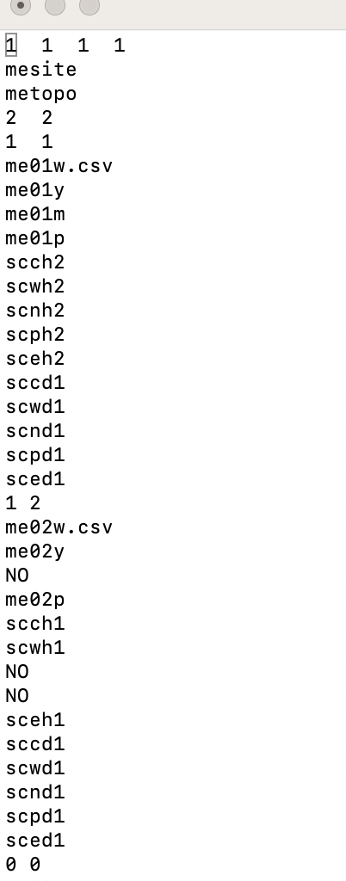

“2 2” means run the following two years (first ”2”) and repeat 2 times (“second 2”).

“1 1” means run the following one script 1 time and repeat 1 time. (e.g., 2000)

“1 2” means run the following one script 1 time and repeat 2 times. (e.g., 2001)

Hence, it will generate 6-year files in total. For example, starting from 2000. It will run 2000 with 2000 weather files (“1 1”) and then proceed to 2001 and 2002 by using 2001 files twice (“1 2”). Then, it will start the second run of “2 2” and go to year 2003 by using 2000 weather files again (”1 1“) and then proceed to 2004 and 2005 by using 2001 files twice (“1 2”), ending with 6 year files.